**Newborn Milk Feedings: Formula vs. Breastmilk**

Patrick Weatherford

Bellevue University – DSC 500 T301 2215-1 Spring 2021

Professor Catherine Williams

Abstract

When babies are born it is often thought that feeding the infant breastmilk has more benefits than feeding formula. Although formula supplementation has made dramatic improvements over the years, many, if not all, well-known and established pediatric and healthcare organizations recommend exclusive breastmilk feedings if possible. “The American Academy of Pediatrics reaffirms its recommendation of exclusive breastfeeding for about 6 months, followed by continued breastfeeding as complementary foods are introduced, with continuation of breastfeeding for 1 year or longer as mutually desired by mother and infant.” (AAP, 2012). To confirm this recommendation, research was performed to find nutrient differences in breastmilk vs. formula, breastmilk feeding rates per state, and Google searches for diseases related to formula-only feedings. After review, it was found that in areas with low breastmilk feedings that there are more searches for “child obesity” and “child diabetes”.

**Newborn Milk Feedings: Formula vs. Breastmilk**

When a baby is born, parents are often faced with the option of feeding an infant breastmilk or formula. It is typically thought that breastmilk is superior over formula and my hypothesis was that this is true. To determine which method of feeding is superior, research will be done to investigate nutrient differences and the effects these differences have on newborn development. The CRISP-DM methodology which is often used for Data Science predictive model implementations will be used as a road map for the way in which the theory is confirmed.

**Differences of Breastmilk vs. Formula**

As technology and research has improved, so has formula effectiveness and safety. Although formula has all the nutrients necessary for a baby to grow, there are obvious benefits from breastmilk that can’t be re-created in formula. “Human milk is a complex body fluid that is variable not only among individuals, but within an individual over time. In addition, it contains components, such as live cells and bioactive compounds, that either cannot be added to formulas or cannot survive a shelf life.” (NCBI 2004).

**Table 1**

*Unique Ingredients Found in Human Breastmilk*

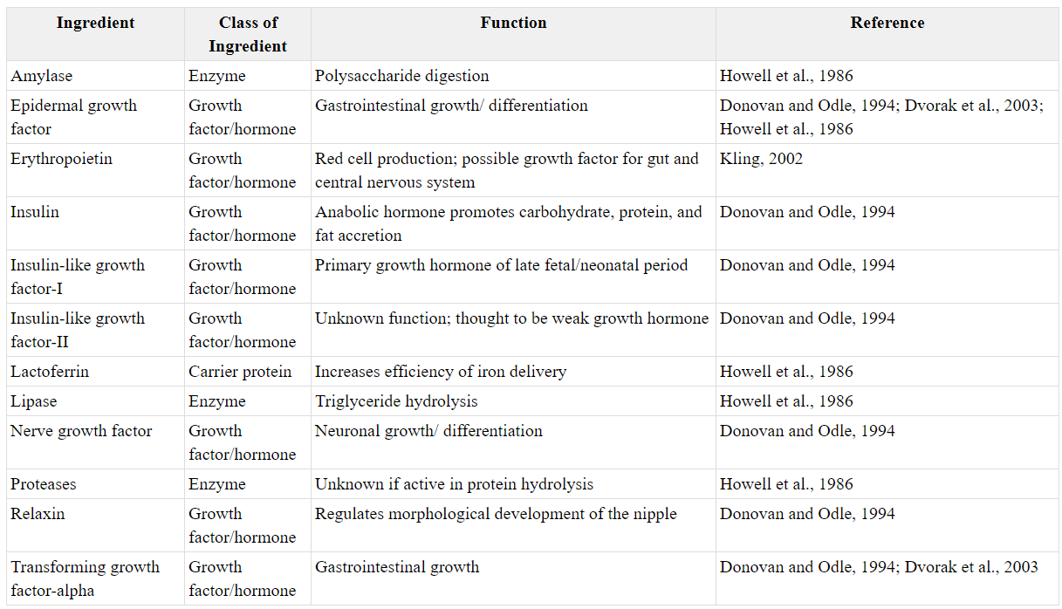

**Effects of Little to No Breastmilk**

So, what are the risks associated with newborns who feed only or primarily on formula and how might we determine if these findings are true? “For infants, not being breastfed is associated with an increased incidence of infectious morbidity, including otitis media, gastroenteritis, and pneumonia, as well as elevated risks of childhood obesity, type 1 and type 2 diabetes, leukemia, and sudden infant death syndrome (SIDS).” (Stuebe, 2009). Knowing these risks, in theory we should see an increase in some of these diseases in areas where breastmilk feeding is lower. Figure 1 below shows states and the rate of breastmilk feedings at 6 months of age.

**Figure 1**

*Percentage of Infants Breastfed at 6 Months*

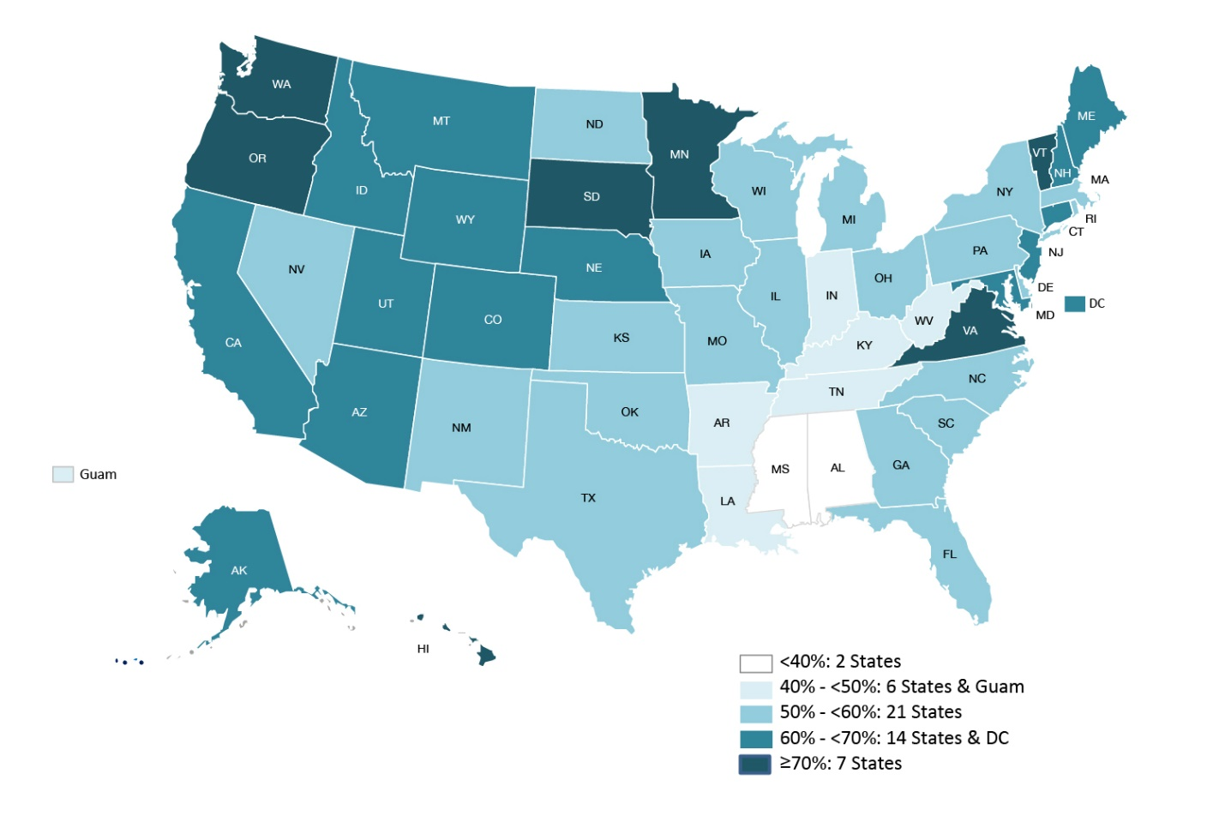

*Note.* CDC. Breastfeeding and the use of human milk. (2012, March 01).

From what the data tells us, we should see an increase in searches for some of the diseases associated with formula only feedings. Below are some of the findings found using Google Trends.

**Figure 2**

*Searches for “Child Obesity”*

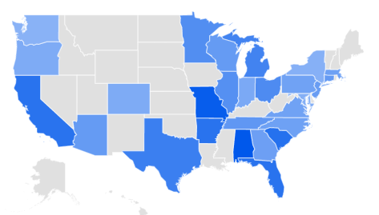

**Figure 3**

*Searches for “Child Diabetes”*

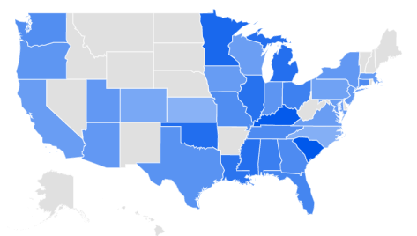

From the data showing breastfeeding rates, Southern and Southeastern states have lower breastfeeding rates at 6 months of age. This seems to correlate somewhat with Google searches for “Child Diabetes” and “Child Obesity”. So, for example, if a state has lower breastfeeding rates, there seem to be more searches for “Child Diabetes” and “Child Obesity”. There are some unexpected results but overall, this seems to hold true.

References

Institute of Medicine (US) Committee on the Evaluation of the Addition of Ingredients New to Infant Formula. Infant Formula: Evaluating the Safety of New Ingredients. Washington (DC): National Academies Press (US); 2004. 3, Comparing Infant Formulas with Human Milk. Available from: <https://www.ncbi.nlm.nih.gov/books/NBK215837/>

American Academy of Pediatrics. Breastfeeding and the use of human milk. (2012, March 01). Available from: <https://pediatrics.aappublications.org/content/129/3/e827>

Stuebe A. (2009). The risks of not breastfeeding for mothers and infants. *Reviews in obstetrics & gynecology*, *2*(4), 222–231.

Breastfeeding and the use of human milk. (2012, March 01). Available from: <https://pediatrics.aappublications.org/content/129/3/e827>